Steps to follow to register on the Wildswinkel App for LIVE and TIMED auctions

Step 1 Download the Wildswinkel App from your Google Play Store or App Store

Step 2 Select Registration

Step 3 Creating your User Profile is a once-off process

Select Profile:
Sign up | Log In
If you have never registered at a Wildswinkel Auction | If you have registered at a Wildswinkel Auction before
Enter First Name, Last Name, Email address | Enter Email address and Password  Click Log In
Click Register
Select ID Type, Country of Issue
Enter ID no and Cell no | If you never received a Password, select Reset Password (you will receive an sms and email with a link to reset your password – select one to reset password)
Click Send OTP
Enter OTP from your sms
Validate OTP
Create and save Password

Step 4 (if prompted, select Skip and Go To Auctions)
Click Register to bid on the Auction you want to register for
- Tick to accept the T&C’s
- Known as (this is the name the Auctioneer will use if a bid falls on you)
- Select Buyer type from dropdown (Online for Timed auction or In Person/Telephone for Live auctions)
- Click on Register as a bidder
- You will receive your buyer no on the screen (you will receive an email / sms as well)

Buyer no’s

- TIMED auction: If you are logged in your buyer no will display on the top right corner
- LIVE auction: Collect your buyer no on the day of the auction at the Pre-registration table
- To view a catalogue for a LIVE auction, select Auctions from the Main App screen

Icons used: Timed auction

List view | Filter (Lot Status/Bid Status/Watchlist/Lot Total/Species)
Grid view | Watchlist
Bid Overview | - Sort (Lot no / time left)

General notes
- You always need to check connectivity No signal =

- To view the detail per lot - Click on Photo or Lot description (in red)

Scroll to the right to see more photos

Bid history is displayed at the bottom

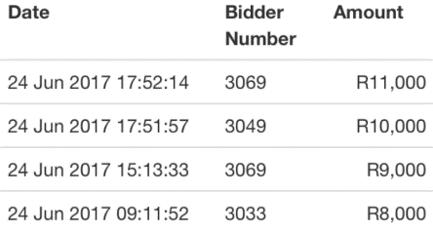

NB! Closing time of lots:
- A lot will not close if a bid is received on the lot within a period of 2 minutes before the closing time of the Timed Auction, as published.
- In this event, the closing time of the lot will automatically be extended for a further period of 2 minutes.
- The lot will only close if a final bid on the lot stands alone for a period of 2 minutes

